### Semester Two Examination, 2020

### Question/Answer booklet

# MATHEMATICS SPECIALIST

**UNITs 3 & 4**

## Section Two:

## Calculator-assumed

|  |
| --- |
|  |

Your Name

Your Teacher’s Name

## Time allowed for this section

Reading time before commencing work: ten minutes

Working time: one hundred minutes

## Materials required/recommended for this section

***To be provided by the supervisor***

This Question/Answer booklet

Formula sheet (retained from Section One)

***To be provided by the candidate***

Standard items: pens (blue/black preferred), pencils (including coloured), sharpener, correction fluid/tape, eraser, ruler, highlighters

Special items: drawing instruments, templates, notes on two unfolded sheets of A4 paper, and up to three calculators approved for use in this examination

## Important note to candidates

No other items may be taken into the examination room. It is **your** responsibility to ensure that you do not have any unauthorised material. If you have any unauthorised material with you, hand it to the supervisor **before** reading any further.

|  |  |  |  |  |  |
| --- | --- | --- | --- | --- | --- |
| **Question** | **Marks** | **Max** | **Question** | **Marks** | **Max** |
| **8** |  | **8 8** | **15** |  | **7** |
| **9** |  | **9 7** | **16** |  | **5** |
| **10** |  | **16** | **17** |  | **6** |
| **11** |  | **8** | **18** |  | **10** |
| **12** |  | **10** |  |  |  |
| **13** |  | **9** |  |  |  |
| **14** |  | **9** |  |

**Structure of this paper**

|  |  |  |  |  |  |
| --- | --- | --- | --- | --- | --- |
| Section | Number of questions available | Number of questions to be answered | Working time (minutes) | Marks available | Percentage of examination |
| Section One:  Calculator-free | 7 | 7 | 50 | 50 | 35 |
| Section Two:  Calculator-assumed | 11 | 11 | 100 | 89 | 65 |
|  |  |  |  | **Total** | 100 |

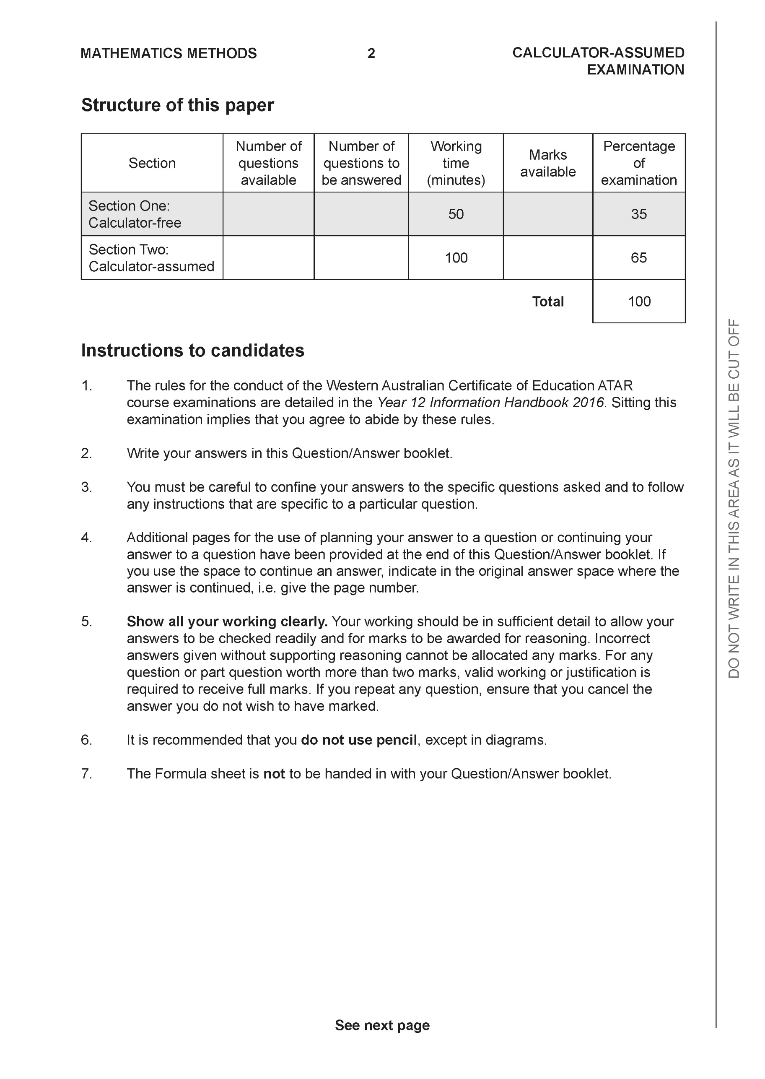

**Section Two: Calculator-assumed (89 Marks)**

This section has **11** questions. Answer **all** questions. Write your answers in the spaces provided.

Spare pages are included at the end of this booklet. They can be used for planning your responses and/or as additional space if required to continue an answer.

● Planning: If you use the spare pages for planning, indicate this clearly at the top of the page.

● Continuing an answer: If you need to use the space to continue an answer, indicate in the original answer space where the answer is continued, i.e. give the page number. Fill in the number of the question that you are continuing to answer at the top of the page.

Working time: 100 minutes.

**Question 8 (8 marks)**

The sketch of the locus  is shown below.

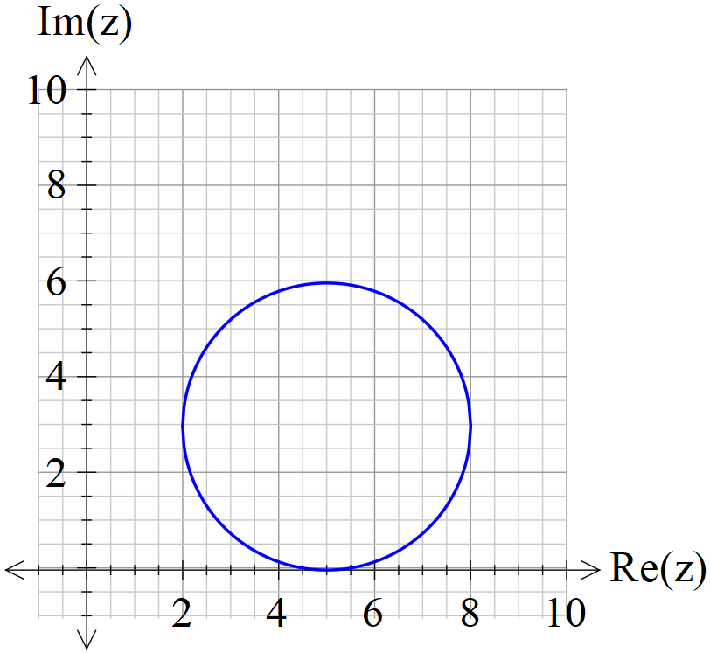

1. Determine an equation for . (3 marks)

|  |
| --- |
| **Solution** |
|  |
| **Specific behaviours** |
| 🗸 uses modulus  🗸 uses centre  🗸 uses radius |

1. Determine the maximum value of  (3 marks)

|  |
| --- |
| **Solution** |
|  |
| **Specific behaviours** |
| 🗸 determines argument of centre  🗸 uses tangent line  🗸 determines max arg |

1. State the value of from the locus above that also satisfy 

(2 marks)

|  |
| --- |
| **Solution** |
| Top of circle |
| **Specific behaviours** |
| 🗸 uses top of circle  🗸 states z |

**Question 9 (7 marks)**

The slope field  is plotted below.

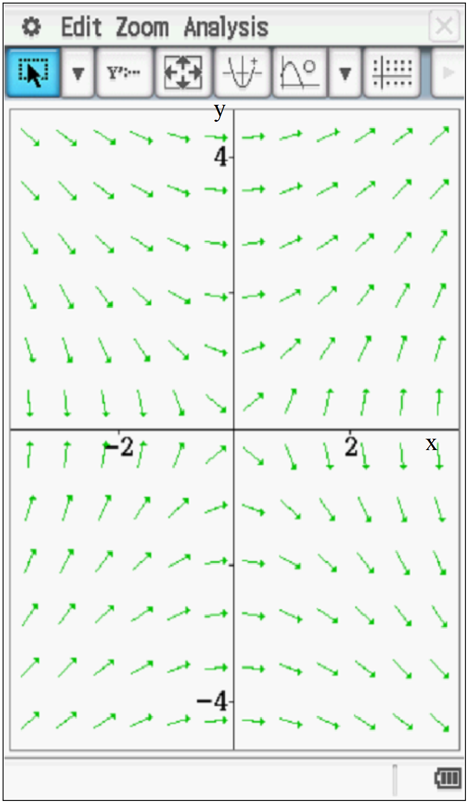

(a) Determine the value of the slope field at point A(2,2). (2 marks)

|  |
| --- |
| **Solution** |
|  |
| **Specific behaviours** |
| 🗸 subs values  🗸 states value |

(b) On the diagram above, sketch the solution curve that passes through A(2,2). (2 marks)

|  |
| --- |
| **Solution** |
|  |
| **Specific behaviours** |
| 🗸 uses line y=x  🗸 stops at origin or shows open circle |

(c) Determine the equation of the solution curve that passes through A(2,2). (3 marks)

|  |
| --- |
| **Solution** |
|  |
| **Specific behaviours** |
| 🗸 separates variables  🗸 solves for general solution  🗸 solves for constant and states that the value is zero |

**Question 10 (10 marks)**

Consider .

1. Determine all roots to the above equation in polar form  with .

(4 marks)

|  |
| --- |
| **Solution** |
|  |
| **Specific behaviours** |
| 🗸 uses De Moivres  🗸 uses polar form  🗸 uses correct mod for all 6 roots  🗸 uses principal argument for all 6 roots |

1. Plot all roots on the diagram below. (3 marks)

|  |
| --- |
| **Solution** |
|  |
| **Specific behaviours** |
| 🗸 states scale  🗸 six dots equally spaced  🗸 all at correct position |

1. Joining these roots will form a polygon, determine the area of this polygon.

(3 marks)

|  |
| --- |
| **Solution** |
|  |
| **Specific behaviours** |
| 🗸 uses 6 equilateral triangles  🗸 uses mod of roots for side lengths  🗸 determines approx. area or exact |

**Question 11 (8 marks)**

Consider the path of a stunt airplane that travels at a constant height according to the following position vector  km at  hours.

1. Plot the starting point of the plane on the above diagram showing the direction of motion. (2 marks)

|  |
| --- |
| **Solution** |
|  |
| **Specific behaviours** |
| 🗸 plots (0,4)  🗸 shows arrow to the right |

1. Determine the initial acceleration. (3 marks)

|  |
| --- |
| **Solution** |
|  |
| **Specific behaviours** |
| 🗸 determines velocity function  🗸 determines acceleration function  🗸 determines initial t=0 |

1. State an expression for the distance travelled in one circuit of the motion, do not evaluate this expression. (3 marks)

|  |
| --- |
| **Solution** |
| Horiz motion period =  Vert motion period =  LCM= = time for one circuit |
| **Specific behaviours** |
| 🗸 determines time for one circuit  🗸 uses magnitude of velocity  🗸 states correct integral |

**Question 12 (10 marks)**

The length of time in minutes that a patient spends with a dentist is normally distributed with a mean of 45 minutes and a population standard deviation of 8 minutes.

A sample of 50 patients is taken as a study of the habits at a particular dental practice.

1. State the approximate sample mean length distribution for the 50 patients. (3 marks)

|  |
| --- |
| **Solution** |
|  |
| **Specific behaviours** |
| 🗸 states Normal  🗸 states mean  🗸 states new standard deviation or variance |

1. Determine the probability that the sample mean length will be less than 35 minutes.

(2 marks)

|  |
| --- |
| **Solution** |
|  |
| **Specific behaviours** |
| 🗸 uses correct parameters  🗸 states prob |

1. Suppose that less than 50 patients were chosen for the sample size, what would happen to the answer in (b) above, do not recalculate. Explain (2 marks)

|  |
| --- |
| **Solution** |
| Area to left will increase as sample mean standard deviation increases |
| **Specific behaviours** |
| 🗸 Area/Prob increases  🗸sample mean standard deviation increases( must mention mean stdev) |

1. It is desired that the probability that the sample mean length time between 43.5 minutes and 46.5 minutes is at least 55%. Determine the minimum sample size for this to occur.

(3 marks)

|  |
| --- |
| **Solution** |
| n=17 |
| **Specific behaviours** |
| 🗸 determines z parameter  🗸 sets up equation to solve for n  🗸 rounds n up |

**Question 13 (9 marks)**

The time taken for a WACE marker to mark a Methods exam paper has a mean of 55 minutes.

A sample of  WACE markers was obtained and the **sample mean** standard deviation was

found to be 12 minutes.

1. Determine a 95% confidence interval for the population mean of marking time to the nearest 0.01 minutes. (3 marks)

|  |
| --- |
| **Solution** |
| 31.48 to 78.52 mins |
| **Specific behaviours** |
| 🗸 uses correct z parameter  🗸 determines lower level rounded to nearest 0.01 mins  🗸 determines upper level |

1. If a sample of  WACE markers was obtained from the same population, determine the standard deviation of this new sample mean. (2 marks)

|  |
| --- |
| **Solution** |
|  |
| **Specific behaviours** |
| 🗸 uses root 3  🗸 states approx. new standard deviation |

1. Which of the two samples above have a greater precision for determining the true population mean . Explain. (2 marks)

|  |
| --- |
| **Solution** |
| Sample of 3n due to smaller standard deviation |
| **Specific behaviours** |
| 🗸 states 3n sample with a reason  🗸 states smaller standard deviation |

1. A 95% confidence interval is determined for the sample of  WACE markers. When compared to the confidence interval calculated in (a) above, which interval contains the true value of ? Explain. (2 marks)

|  |
| --- |
| **Solution** |
| We do not know which interval contains the true value of population mean. A confidence interval does not always contain true value. |
| **Specific behaviours** |
| 🗸 states that we do not know  🗸 explains that not all intervals contain mean |

**Question 14 (9 marks)**

Consider the sphere given by the following cartesian equation .

1. Determine the vector equation of this sphere. (3 marks)

|  |
| --- |
| **Solution** |
|  |
| **Specific behaviours** |
| 🗸 completes the square for each variable  🗸 determines cartesian equation with centre and radius readily seen  🗸 determines vector equation |

Consider a second sphere  given by .

1. Determine the distance of the centre of from the plane . (3 marks)

|  |
| --- |
| **Solution** |
|  |
| **Specific behaviours** |
| 🗸 uses a pt on plane  🗸 uses dot product with unit normal vector  🗸 determines approx. distance |

1. Is the line  a tangent to the sphere ? Explain. (3 marks)

|  |
| --- |
| **Solution** |
| Therefore line is not a tangent as does not intersect with sphere at all |
| **Specific behaviours** |
| 🗸 sets up equation for parameter  🗸 shows that there is no solution for parameter  🗸 states that not a tangent as does not intersect with sphere at all |

**Question 15 (7 marks)**

1. By using integration and partial fractions, show that the solution to the differential equation  is  where  are constants for time  hours. ( initial value of P) (4 marks)

|  |
| --- |
| **Solution** |
|  |
| **Specific behaviours** |
| 🗸 uses partial fractions  🗸 solves for constants for partial fractions  🗸 integrates to find a correct expression for P  🗸 rearranges constants to required formula |

1. Let  represent the number of bacteria cells present on a laboratory tray at time  hours. The initial number being 300 cells and the rate of change given by

.

Determine the approximate number of bacteria cells after 8 hours. (3 marks)

|  |
| --- |
| **Solution** |
|  |
| **Specific behaviours** |
| 🗸 determines values of all constants  🗸 uses an appropriate formula  🗸 determines approx. value at 8 hours |

**Question 16 (5 marks)**

Consider person B ridding on a merry go round at an angular speed of 12 rad/sec clockwise and person A moving towards the centre of the merry go round at a speed of 3 m/sec. Initially person A is 25 m from the centre and the angle for person B is . Determine the initial rate of change of the distance between persons A & B.

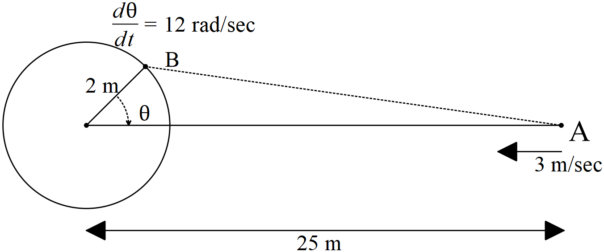

|  |
| --- |
| **Solution** |
|  |
| **Specific behaviours** |
| 🗸 uses cosine rule  🗸 determines distance initially between people  🗸 uses implicit did with chain and product rules  🗸 sets up equation for desired rate  🗸solves for initial rate |

**Question 17 (6 marks)**

Consider the following two planes;



1. Determine the distance between the two planes. (4 marks)

|  |
| --- |
| **Solution** |
| Choose pt on each plane  A(0,0,9/7)  B(0,0,6/7) |
| **Specific behaviours** |
| 🗸 determines apt on each plane  🗸 uses a separation vector or vector line equation  🗸 uses dot product with unit normal  🗸 determines approx. distance |

1. Consider the point , derive an expression for the distance of this point to the plane  above. (2 marks)

|  |
| --- |
| **Solution** |
|  |
| **Specific behaviours** |
| 🗸 uses separation vector  🗸 uses dot product with unit normal and absolute value |

**Question 18 (10 marks)**

Consider an object moving with motion  where  is the displacement from the origin in metres at time  seconds. The initial displacement is 5 metres given that the velocity is zero when metres.

1. Determine the displacement at any time  seconds. (2 marks)

|  |
| --- |
| **Solution** |
|  |
| **Specific behaviours** |
| 🗸 determines all constants  🗸 uses an appropriate model for x |
|  |
|  |
|  |
|  |
|  |
|  |
|  |
|  |
|  |
|  |
|  |
|  |
|  |
|  |
|  |
|  |
|  |
|  |
|  |
|  |
|  |
|  |
|  |
|  |
|  |
|  |

1. Determine the percentage of time that the distance from the origin is between 2 and 7 metres. (4 marks)

|  |
| --- |
| **Solution** |
| Percentage is 42.5% |
| **Specific behaviours** |
| 🗸 solves for a time dist=2  🗸 solves for a time dist=7  🗸 uses a known interval in aperiodic cycle  🗸 determines approx. percentage |

1. Show by **using integration** that for  the following can be derived  where  equals the amplitude. (4 marks)

|  |
| --- |
| **Solution** |
|  |
| **Specific behaviours** |
| 🗸 uses separation of variables  🗸integrates both sides  🗸solves for constant in terms of amplitude  🗸states required formula |

Additional working space

Question number:

**Acknowledgements**